**UNIVERSITY OF HERTFORDSHIRE**

**SCHOOL OF ENGINEERING AND TECHNOLOGY**

**Broadband Networks and Data Communication (7ENT1050)**

Lab Experiment on Linear Transceiver Design for MIMO Radio Communication Link

**Objectives**

* Understand the impact of the multiple antennas in the communications (from DMD)
* Design the transmit and receive beamforming matrix for the MIMO communication link(from DMD)
* Design the optimal transmit power allocation and evaluate the impact of the transmit power budget and the number of antennas in achievable rate(from DMD)

**Introduction:**

The current mobile cellular networks, e.g., Long-Term Evolution (LTE), aim to provide high data rate for the mobile users, by deploying multiple antennas at the base stations. The multiple antenna array enables to form directional beams for the desired mobile users to combat the path loss fading and simultaneously transmit multiple independent data streams by benefiting the multiplexing gain.

Therefore, this experiment considers a multiple-input-and—multiple-output (MIMO) radio communication link, where the transmitter and receiver are equipped with multiple antennas. The transmitter power is subject to a maximal transmit power budget due to the physical limit. This assignment focus on the optimal beamforming design to achieve the maximum capacity of the MIMO point-to-point communication link. The Matlab programming is expected in the tasks.

Assignment Assessment:

* The final report addressing all the tasks should be submitted before the deadline (**Deadline: Friday13thApril 2018 16.00**).
* The one-to-one viva (oral presentation with powerpoint slides) will be done in the last lab **Tuesday 17th April 2018 13.00-15.00.**

Before you proceed to simulation, it is recommended to learn about fundamental knowledge and the theory.

1. **Briefly explain the fundamentals ofbeamforming design for MIMO communication link**

Consider the following MIMO communication link shown in the Figure1.

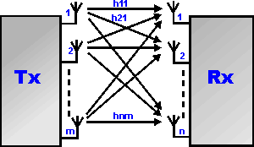

**Figure 1. MIMO point-to-point communication link**

The transmitter (Tx) and the receiver (Rx) are equipped with*nt* and *nr*antennas, respectively. It is desired to transmit *Ns*independent symbols simultaneously from the Tx to the Rx through the channel **H**, where **H** is an *n*-by-*m* complex matrix and is modelled as independently and identically distributed (i.i.d.) Rayleigh fading channel.

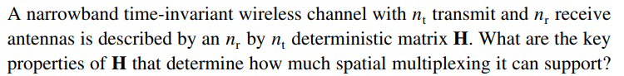

This assignment is aimed to give the answer to this question by looking at the capacity of the channel and numerically simulated for different system parameters.

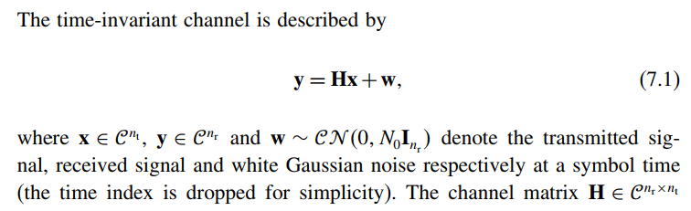

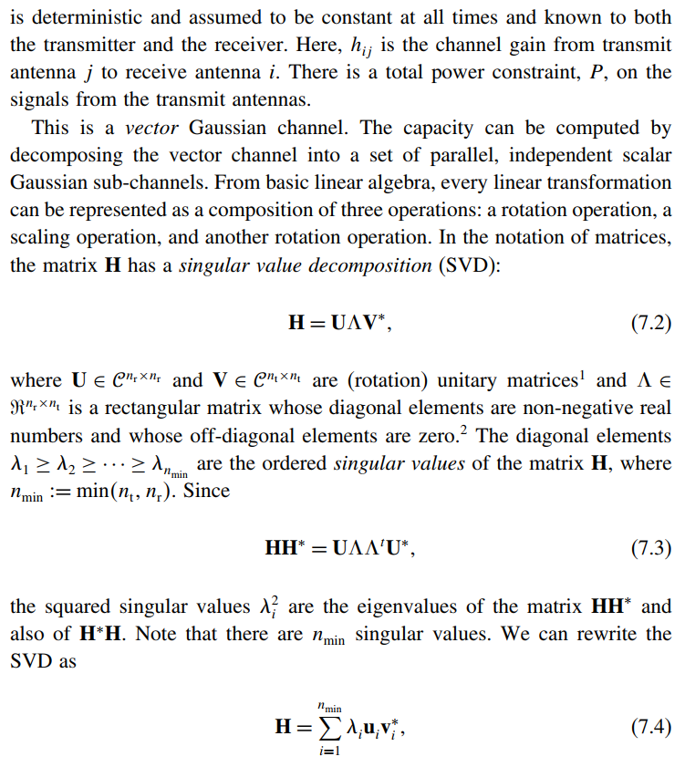

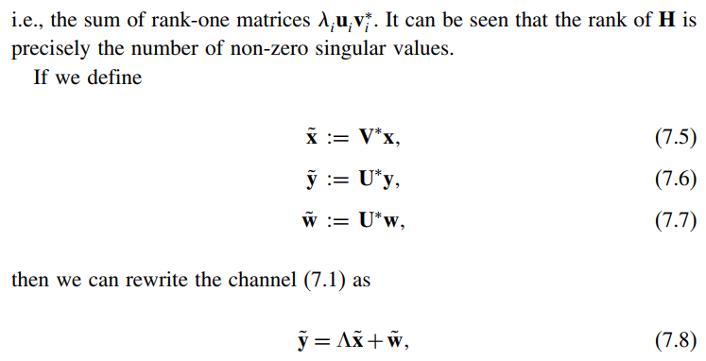



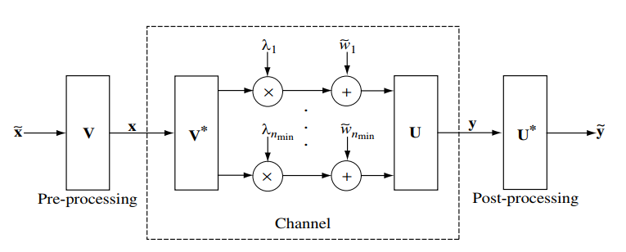

**Figure 2. Converting the MIMO channel into a parallel channel through the SVD.**



Thus, the energy is preserved and we have an equivalent representation as a parallel Gaussian channel:



The equivalence is summarised in Figure 2.

The SVD decomposition can be interpreted as two coordinate transformations: it says that if the input is expressed in terms of a coordinate system defined by the columns of V and the output is expressed in terms of a coordinate system defined by the columns of U, then the input/output relationship is very simple. Equation (7.8) is a representation of the original channel (7.1) with the input and output expressed in terms of these new coordinates. Given the full channel state information, the capacity can be expressed as

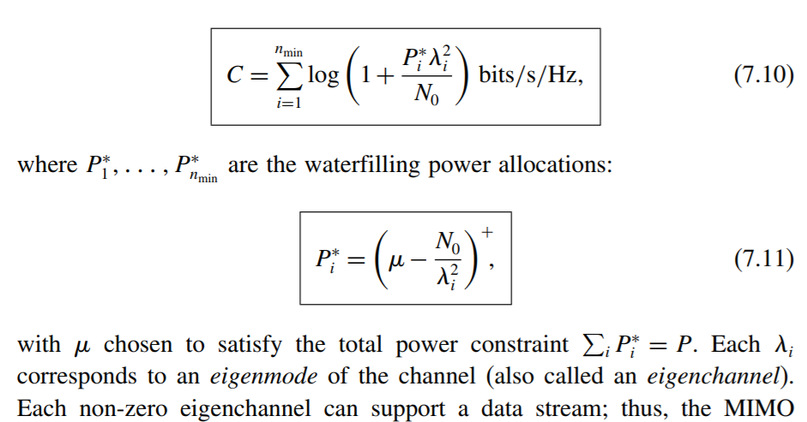

channel can support the spatial multiplexing of multiple streams. Figure 3 pictorially depicts the SVD-based architecture for reliable communication.

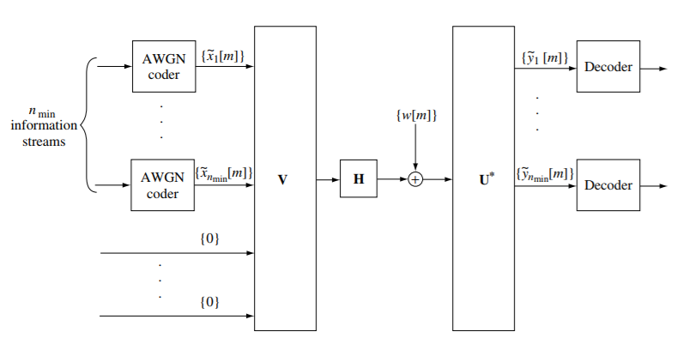

**Figure 2. The SVD architecture for MIMO communication.**

The water-filling power allocation solution in Eq. (7.11) can be illustrated in Figure 3, where thewater level, i.e., µ inEq. (7.11), can be determined by checking out the condition that the sum transmit power of all the data streams is equal to the maximum transmit power budget. Then, for the positive transmit power, the corresponding subchannels are active and will be used for the data stream transmission. Otherwise, those subchannels will not be used if their allocated power are zeros.

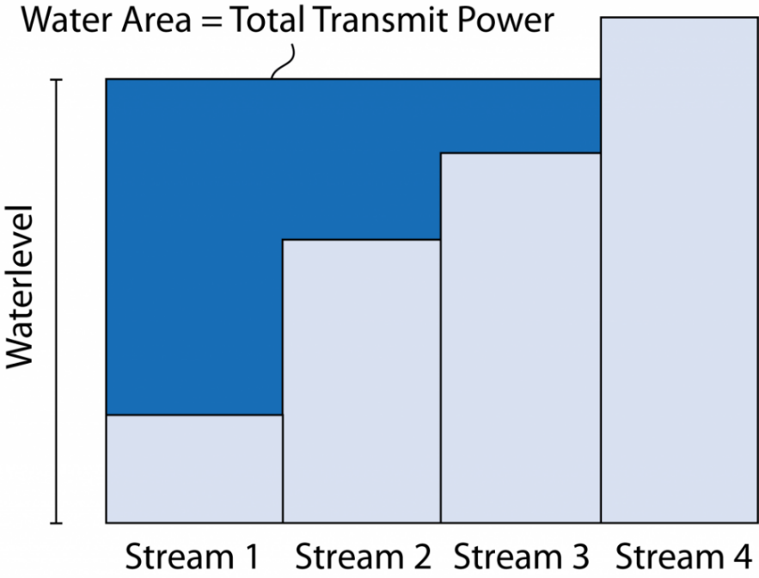

**Figure 3. Illustration example for water-filling power allocation. The first three largest singular values (subchannels) will be selected and the fourth subchannel will be inactive.**

1. **Transmit and Receive Beamforming Design**

This task is to implement the derivation to the above Eq. (7.10) by Matlab programming.

The Matlab functions can be found in the Reference [2]. You can also find the details of each function by using Matlab help. For example, you can use ‘help eig’ to find how to use the eig function.

Let **F** and **G** denote the transmit and receive beamforming matrix, based on the SVD of **H**, please derive the optimal transmit and receive beamforming matrices **F**\* and **G**\*, which enable to maximize the MIMO channel capacity

*C* = logdet(**I** + **G**H**HFF**H**H**H**G**). (7.12)

*Subject to* **G’*G**=**I** *and trace*(**F*F’**)*<= Pmax*where *Pmax* denotes the maximum transmit power budget at the transmitter;

*Note:* ***X’*** *and* ***X****Hdenotes the same operation of* ***X****.*

**Numerical Simulation Parameter Setting:**

*Speed of light: 3*108 meters/second*

*Carrier frequency:* 1.2 GHz

*Transmission bandwidth:* 20 MHz

*The number of transmit antennas:*Nt

*The number of receive antennas:*Nt /2

*Tx-Rx distance:* 300 meters

*Path loss model*: free space path loss [3]

FSPL = (4*pi*distance/wavelength)2 (7.13)

*Maximum Transmit Power to Noise Ratio (MTPNR):*40 dB

*Received noise power:*1 (normalised)

Step2a. Start the Matlab software, and creat a new document (ctrl + N);

Step2b. Set the above system settings and *Nt*= 8 + 4\**group no*;*Nr = Nt/2;*

**Question 1:**Calculate the free space path loss FSPL according to Eq. (7.13) and the maximum transmit power budget *Pmax* according the value of MTPNR and the normalised received noise power (insert the answers below this question);(5%)

FSPL = (4*pi*distance/wavelength)2 =2.2740e+08

MTPNR=10log (Pmax/N)

40dB=10log (Pmax/1)

Pmax=10000 W

Step 2c. Generate an *Nr*-by-*Nt* complexindependent and identically distributed channel matrix **H0**, where each element of **H0** satisfies zero mean and unit variance and generate the channel matrix **H** = (FSPL)-1/2**H0** that will be used for the following simulation. Make sure that you should use the same H for all the following questions.(Tip: you can save the H data and load the H data for each simulation run)

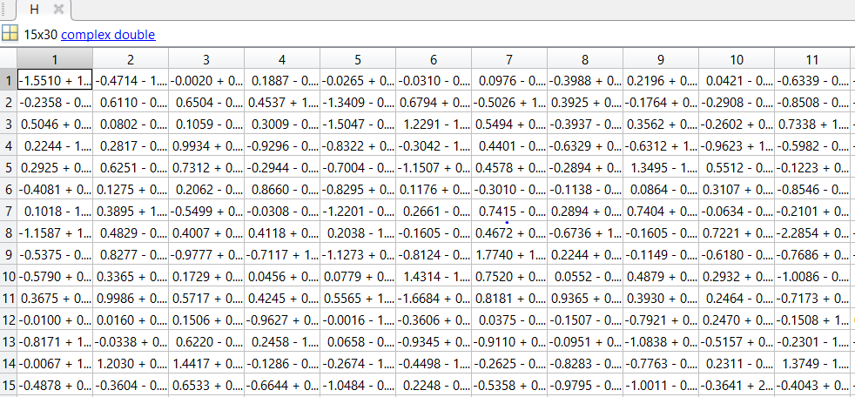

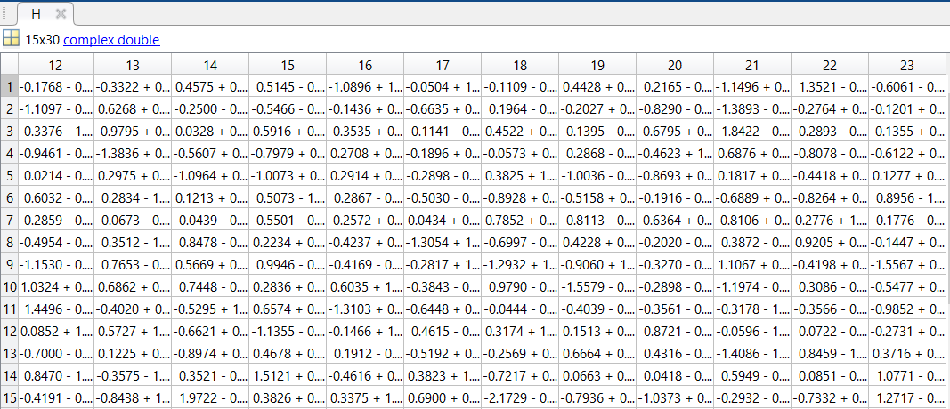

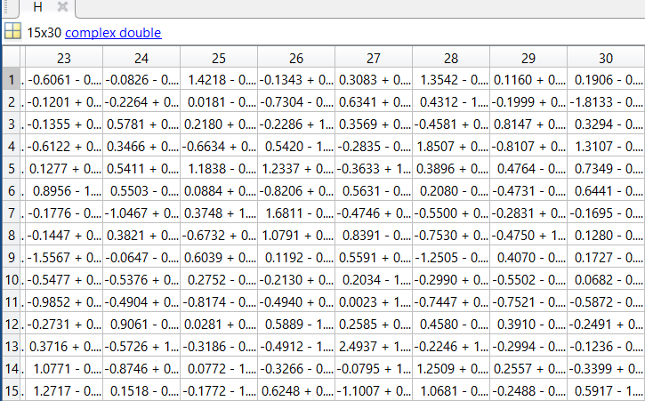

Step2d. Find the eigenvalues and eigenvectors of **H’*H;**

**Question 2.** Plot the eigenvalues for **H’*H** in **decreasing order** and insert the figure below this question:(5%)

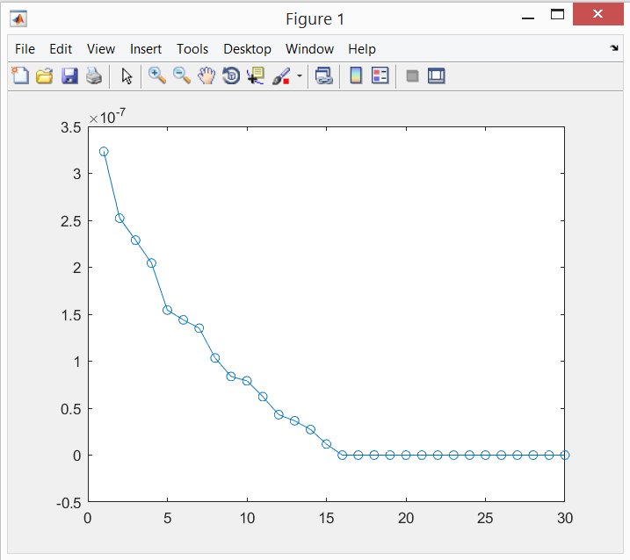

Step2e. Let **U** and **D** denote the eigenvector matrix and eigenvalue matrix of **H’*H,** reconstruct a matrix **A**= $\sum_{n=1}^{Nt}{D(n,n)*U(:,n)*U(:,n)’ }$ where $D\left(n,n\right)$ and $U(:,n)$ denote the n-th diagonal element of matrix **D** and the n-th column of matrix **U**.

A=H'*H;

E=eig(A);

K1=sort(real(E),'descend');

figure, plot(K1,'o-')

[U,D] = eig(A);

B=zeros(Nt,Nt);

for n=1:Nt;

B=B+D(n,n)*U(:,n)*U(:,n)';

end;

**Question 3.**Compare the eigenvalues of **A** with the diagonal elements of **D**, and explain the reason.(5%)

A=H'*H;

E=eig(A);

K1=sort(real(E),'descend');

figure, plot(K1,'o-')

[U,D] = eig(A);

B=zeros(Nt,Nt);

for n=1:Nt;

B=B+D(n,n)*U(:,n)*U(:,n)';

end;

K=eig(B);

K2=sort(real(K),'descend');

hold on,plot(K2,'*--');

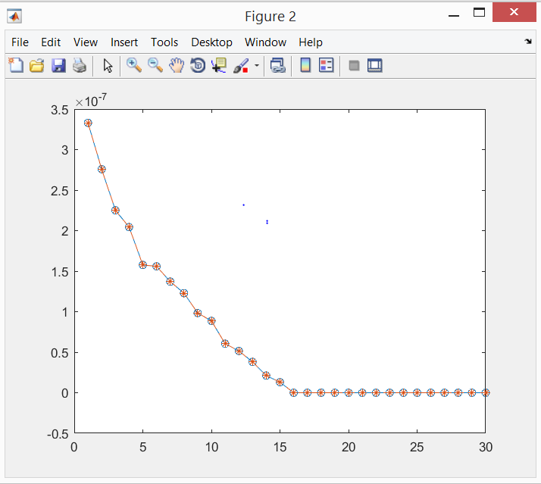

They are equal.

Step2f. Do the singular value decomposition for the matrix **H**as **H = Us*Ds*Vs’** where**Us, Vs** and **Ds** denote the left singular vector matrix, the right singular vector matrixand the singular value matrix, respectively.

[Us,Ds,Vs]=svd(H);

**Question 4.** 1)Observe if the product **Us’*H*Vs** is a diagonal matrix or not and explain the reason. 2) Compare the singular values, i.e., the diagonal elements of **Ds**with the eigenvalues of**H’*H**, i.e., the diagonal elements of **D** and explain the reason for this.(5%)

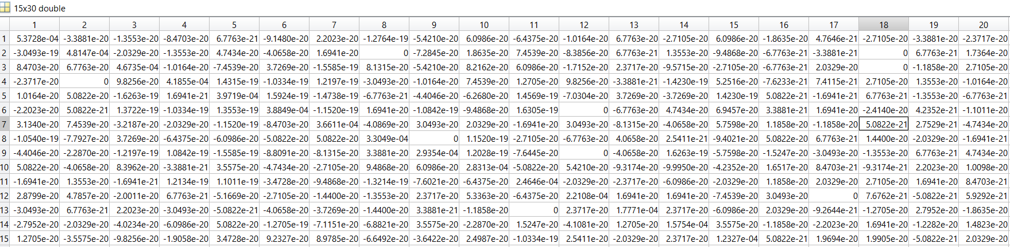

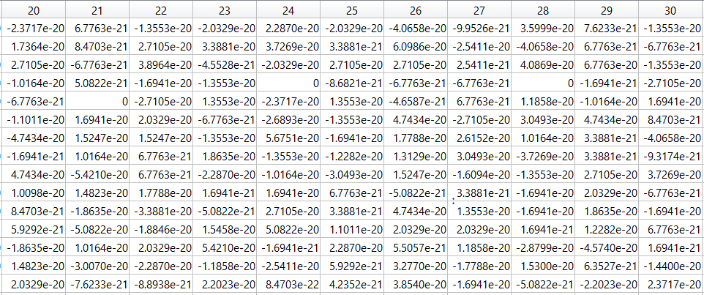

The product is a diagonal matrix and that’s because H is being multiplied by unitary matrices Us and Vs.

The singular values are equal to the root squared elements of the eigenvalues of H’*H.

**Question 5.**1) Count the total number of subchannels, i.e., the number of non-zero (greater than 1e-6) singular values of the matrix **H**, and denote this number as Nall.(5%) 2) Let us assume that the maximum transmit power Pmax obtained in Question 1 is **equal**ly allocated to N subchannels, where N=1,…,Nall. Give the corresponding transmit beamforming matrix **F**and the receive beamforming matrix **G**that can diagonalise the matrix **H**.(5%) 3) Plot the data rate

Rate = bandwidth*C, [symbols/second](7.14)

vs N=1,…,Nall and insert the figure below the question(5%).

The beamforming matrix F is equal to Us’ and the receive beamforming matrix is G which is equal Vs.

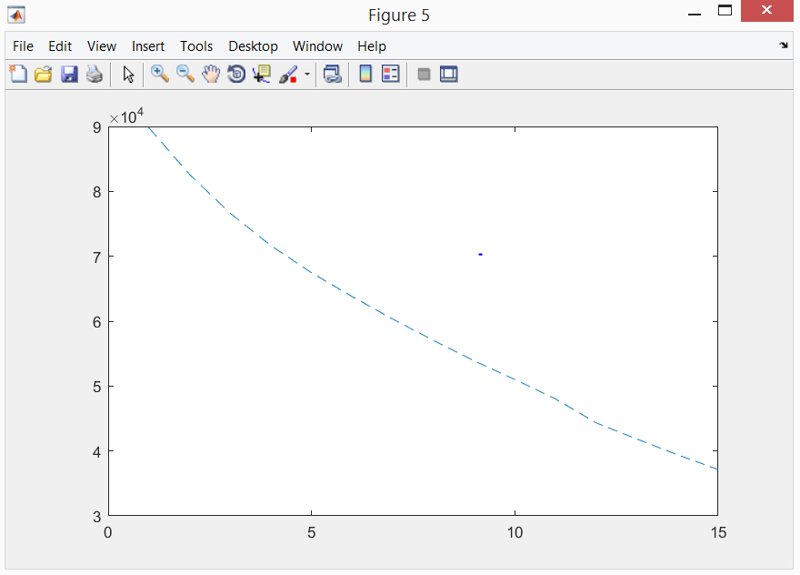

As the number of sub channels grows, the data rate decreases.

**Question 6.**Based on the water-filling power allocation expression in Eq. (7.11) and Figure 3, find the water-filling power allocation result and the data rate based on Eq. (7.14).Give the results below the question.(Tip: using bisection search method [4] to find the water level µ in Eq. (7.13))(25%)

SingularValues=find(Ds>1e-6);

mu=1000;

epsilon=1e-9;

Pi=subplus(mu-(1./(SingularValues.^2)));

if sum(Pi)>Pmax

mu=mu-mu/2;

Pi=subplus(mu-(1./(SingularValues.^2)));

end

if sum(Pi)<Pmax-ee

mu=mu+mu/2;

Pi=subplus(mu-(1./(SingularValues.^2)));

end

if Pmax>sum(Pi)&& sum(Pi)>Pmax-ee

save mu

end;

c=(log2(1+Pi.*(SingularValues.^2)));

r=BW*c;

**Useful Bibliography**

1. D. Tse and P. Viswanath, "Fundamentals of Wireless Communication," Cambridge University Press, Chapter 7, pp. 290-331, 2005. Available: <https://web.stanford.edu/~dntse/Chapters_PDF/Fundamentals_Wireless_Communication_chapter7.pdf>
2. Johnson, Richard, "Antenna Engineering Handbook" (2nd ed.). New York, NY: McGraw-Hill, Inc., p. 1-12. 1984.
3. Matlab functions – By Category <https://uk.mathworks.com/help/matlab/functionlist.html?s_cid=doc_ftr>
4. [Weisstein, Eric W.](https://en.wikipedia.org/wiki/Eric_W._Weisstein) ["Bisection"](http://mathworld.wolfram.com/Bisection.html). [MathWorld](https://en.wikipedia.org/wiki/MathWorld).<https://en.wikipedia.org/wiki/Bisection_method>

THE END